Computer PROGRAMMING LAB
(3+1 Credit Hours)
CSL-113
FLIGHT MANAGEMENT SYSTEM
Project Report



Couse Instructor: Ms. Azeema Sadia
Lab Instructor: Ms. Hafsa Munawar
Class Section: BSCS 1A
Semester: Spring 2024
Group Members:
Enrollment | Name
02-134241-048 | SABA SHAHID
02-134241-018 | JIBRAIL AMEEN
02-134241-004 | IBAD UR REHMAN

DEPARTMENT OF COMPUTER SCIENCE
BAHRIA UNIVERSITY, KARACHI, PAKISTAN

Table of Content:
Introduction: 3
1. Background: 3
2. Problem Statement or Motivation 4
3. Scope 4
4. Objectives 4
Methodology: 5
1. Tools and Technologies 5
2. Algorithm 5
3. Flow Diagram 5
Implementation: 6
1. Key Features 6
2. Functionalities 6
3. Inputs 7
Modules 7
4. Outputs 8
5. Code Snippets 8
Conclusion: 23
Screenshot 23

Introduction:
The Flight Management System is designed to assist users in planning their travel itineraries efficiently. Leveraging fundamental programming concepts such as loops, arrays, functions, if-else statements, and switches, our system provides a user-friendly experience. Implemented as a console application, it features a straightforward user interface and clear instructions, ensuring accessibility for a wide audience.
The application guides users through the process of creating a detailed travel plan by offering options to input destinations, schedule activities, and manage travel times. By incorporating various programming techniques, it ensures that the data is processed swiftly and accurately, providing users with immediate feedback and suggestions. This makes the program not only efficient but also responsive to user needs, enhancing the overall planning experience.
Key features of the Flight Management System include destination management, where users can add, remove, and view destinations in their itinerary. It also offers activity scheduling, allowing users to plan activities for each destination, including times and durations. The travel time calculation feature automatically computes travel times between destinations and adjusts the itinerary accordingly, ensuring a smooth travel experience. Additionally, the program enables customization based on user preferences, such as preferred travel methods and activity types, making it adaptable to various travel styles and needs.
Designed to be intuitive, the console application makes it easy for users of all technical backgrounds to navigate and utilize its features effectively. The underlying code structure ensures robustness and flexibility, allowing for future enhancements and scalability. This comprehensive approach ensures that users can plan their travel itineraries with ease and confidence, knowing that the Flight Management System will support their planning needs efficiently.

Background:
In today's fast-paced world, efficient travel planning has become essential for travelers to navigate through the myriads of options and information available. Traditional methods, such as relying on travel agents or manually gathering data, often prove to be time-consuming and prone to errors. Moreover, existing digital travel planning tools are either overly complex or lack fundamental features, rendering them inaccessible to users with limited technical skills.
Recognizing these challenges, our Flight Management System project emerged with the aim of simplifying travel planning through a user-friendly console application. Focused on core functionalities such as flight selection, accommodation booking, and activity scheduling, our system seeks to streamline the process, making it more efficient and less stressful for travelers.
By developing the system as a console application, we ensure its accessibility to a broad audience while maintaining a lightweight and platform-independent design. Deliberately excluding advanced features like real-time travel updates and external booking system integration allows us to prioritize simplicity and usability, avoiding feature overload that could complicate the user experience.Overall, the background of our Flight Management System project underscores the increasing need for efficient and accessible travel planning solutions. By providing a streamlined platform that addresses the core needs of travelers, we aim to enhance the overall travel experience and empower users to plan their trips with ease and confidence.

Problem Statement or Motivation
Efficient travel planning is crucial in today's fast-paced world, where travelers face an overwhelming amount of information and choices. Traditional travel planning methods, such as using travel agents or manually compiling data, are often time-consuming and error-prone. Existing digital tools are either too complex or lack essential features, making them inaccessible to users with limited technical skills. Our Flight Management System project addresses these challenges by offering a streamlined, user-friendly console application focused on core functionalities: flight selection, accommodation booking, and activity scheduling. This approach simplifies the travel planning process, making it more efficient and less stressful. By implementing the system as a console application, we ensure it remains lightweight and platform-independent, accessible to a broad audience. We deliberately exclude advanced features like real-time travel updates and integration with external booking systems to avoid feature bloat and maintain simplicity.

Scope
The Flight Management System project extends its scope to include not only the core functionalities of itinerary planning but also aspects of user engagement and system optimization. This entails implementing features that enhance user interaction, such as personalized recommendations based on past travel preferences and seamless integration with social media platforms for sharing travel plans. Furthermore, we prioritize system optimization by implementing efficient algorithms for itinerary generation and travel time calculations, ensuring swift and accurate processing of data. While our focus remains on simplicity and usability, we also recognize the importance of staying abreast of industry trends and technological advancements to continually enhance the capabilities of our system. Additionally, our project may explore potential partnerships with airlines or travel agencies to provide users with exclusive deals and offers, further enhancing the value proposition of our Flight Management System. By adopting a holistic approach to system development and collaboration, we aim to create a robust and versatile platform that meets the evolving needs of modern travelers.

Objectives
The objectives of our Travel Management System project are as follows:
- Simplify Travel Planning: Develop a user-friendly platform that simplifies the process of planning trips for users of varying levels of technological proficiency.
- Save Time: Develop features that help users quickly find and book everything they need for their trip, saving them time and hassle.

- Give Useful Recommendations: Offer personalized suggestions and recommendations to help users make informed decisions about their travel plans

Methodology:

Tools and Technologies
- Software Tool: Microsoft Visual Studio 2022
- Programming Language: C++

Algorithm

Initialization Phase
- Initialize System
  - Call initSystem to set up the system by creating an initial admin user using addAdminUser.

Main Menu Loop
- Display Main Menu
  - Clear screen using clearScreen.
  - Display options: Admin, Crew, Passenger, Exit.
  - Get user's choice.
- Handle User Choice
- If Admin is chosen, call adminSignIn.
  - If sign-in is successful, display Admin Menu by calling showAdminMenu.
  - If sign-in fails, show an error message and prompt to continue.
- If Crew is chosen, prompt for username, then call showCrewMenu with the entered username.
- If Passenger is chosen, display Passenger Menu by calling showPassengerMenu.
- If Exit is chosen, exit the program.
- For invalid choice, display an error message.

Admin Menu
- Admin Sign-In
  - Prompt for admin username and password.
  - Validate credentials against admin.txt file contents.
  - Return true if credentials match; otherwise, return false.
- Admin Menu Loop
- Clear screen and display Admin Menu options.
- Get admin's choice.
- Based on the choice:
  - Add Flight Schedule: Call addFlightSchedule.
  - Change Flight Schedule: Call changeFlightSchedule.
  - Assign Crew to Flight: Call assignCrewToFlight.
  - Add Crew Member: Call addCrewMember.
  - Back to Main Menu: Return to the main menu loop.
- For invalid choice, display an error message

Crew Menu
- Crew Sign-In
  - Prompt for crew member username and password.
  - Authenticate credentials using authenticateCrewMember.
  - If credentials are valid, proceed to Crew Menu.
  - If invalid, show an error message and prompt to continue.
- Crew Menu Loop
- Clear screen and display Crew Menu options.
- Get crew member's choice.
- Based on the choice:
  - Show Current Schedule: Call showCurrentSchedule with the crew member's username.
  - Show History of Past Flights: Call showHistoryOfPastFlights with the crew member's username.
  - Back to Main Menu: Return to the main menu loop.
- For invalid choice, display an error message.

Passenger Menu
- Passenger Menu Loop
  - Clear screen and display Passenger Menu options.
  - Get passenger's choice.
  - Based on the choice:
    - Book Flight: Call bookFlight.
    - Display Available Flights: Call displayAvailableFlights.
    - Back to Main Menu: Return to the main menu loop.
  - For invalid choice, display an error message.

Flight and Crew Member Operations
- Add Flight Schedule
  - Prompt for flight details: flight number, origin, destination, departure time, arrival time, available seats.
  - Save flight details using saveFlight.
  - Display success message and prompt to continue.
- Change Flight Schedule
  - Load existing flights using loadFlights.
  - Prompt for flight number to change.
  - If flight is found, prompt for new details and update the schedule using updateFlightSchedule.
  - If flight is not found, display an error message.
  - Free the allocated memory for flights.
- Display Available Flights
- Load existing flights using loadFlights.
- Display flight details.
- Free the allocated memory for flights and prompt to continue.
- Book Flight
- Load existing flights using loadFlights.
- Prompt for flight number and passenger's age.
- Calculate ticket price using getTicketPrice.
- If available seats exist, decrement seat count and update schedule using updateFlightSchedule.
- Display success message with ticket price.
- If no seats are available or flight is not found, display an error message.
- Free the allocated memory for flights and prompt to continue.
- Assign Crew to Flight
- Load existing flights and crew members using loadFlights and loadCrewMembers.
- Prompt for flight number and crew member username.
- If both are found, assign the flight to the crew member and update the crew members using updateCrewMembers.
- If not found, display an error message.
- Free the allocated memory for flights and crew members and prompt to continue.
- Show Current Schedule
- Load existing crew members using loadCrewMembers.
- Find crew member by username and display their assigned flights.
- Free the allocated memory for crew members and prompt to continue.
- Show History of Past Flights
- Load existing crew members using loadCrewMembers.
- Find crew member by username and display their past flights.
- Free the allocated memory for crew members and prompt to continue
- Authenticate Crew Member
- Load existing crew members using loadCrewMembers.
- Check if the entered username and password match any crew member.
- Return true if credentials match; otherwise, return false
- Save and Load Data
- saveUser, loadUsers: Save/load user data to/from users.txt.
- saveFlight, loadFlights, updateFlightSchedule: Save/load/update flight data to/from flights.txt.
- saveCrewMember, loadCrewMembers, updateCrewMembers: Save/load/update crew member data to/from crew.txt.
- Ticket Pricing
- getTicketPrice: Calculate ticket price based on passenger's age.
- Add Crew Member
- Prompt for crew member details: username, password, name, position.
- Save crew member details using saveCrewMember.
- Display success message and prompt to continue
- Add Admin User
- Write default admin user credentials to admin.txt

Utility Functions
- Clear Screen
  - Clear console screen using ANSI escape codes.
- Press Enter to Continue
  - Prompt user to press Enter to continue.

Flow Diagram
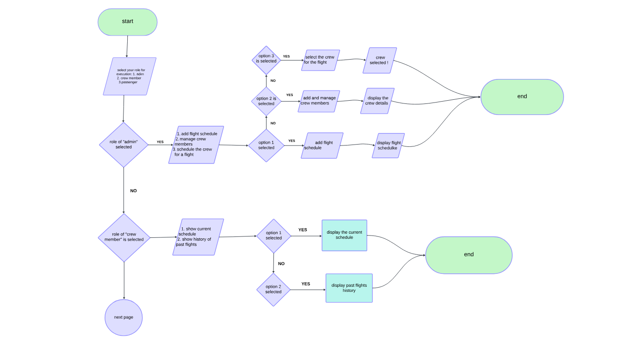
Figure 3.0.1 flow chart part 1
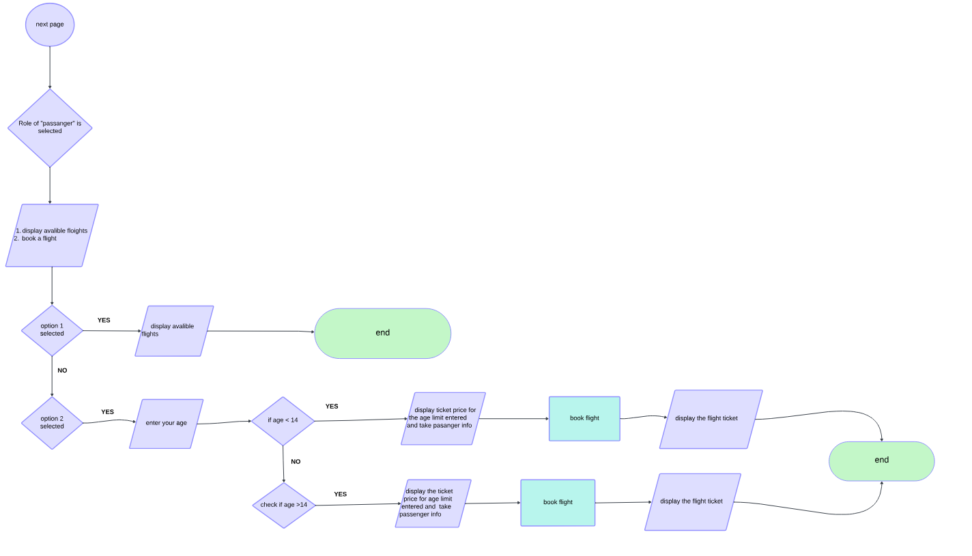

Figure 3.2 Flow chart part 2

Implementation:

Key Features
- Functionality: What the project does and the core problems it solves. This could be managing tasks, automating processes, analyzing data, or creating content.
- Usability: How easy and intuitive the project is to use. This includes a user-friendly interface, clear instructions, and well-organized features.
- Performance: How efficiently and quickly the project completes tasks. This considers factors like speed, responsiveness, and resource usage.
- Scalability: The ability of the project to handle an increasing workload or data volume. This is important for projects that are expected to grow over time.
- Security: Measures taken to protect user data and system integrity. This includes authentication, authorization, and encryption.

Functionalities
- Core functionalities: The essential actions or tasks that the project performs to achieve its goals.
- Secondary functionalities: Additional features that enhance the user experience or provide more advanced capabilities.
- Integrations: The ability to connect with other tools or services to expand functionality.
- Inputs

Modules
Admin Module:
- Admin username and password for authentication.
- Selection of admin tasks such as adding flight schedules, changing flight schedules, assigning crew to flights, and adding crew members.
Crew Module:
- Crew member username and password for authentication.
- Selection of tasks such as viewing current schedule and history of past flights.
Passenger Module:
- Selection of tasks such as booking a flight or displaying available flights.
Add Flight Schedule:
- Flight number.
- Origin airport.
- Destination airport.
- Departure time.
- Arrival time.
- Number of available seats.
Change Flight Schedule:
- Flight number of the schedule to be changed.
- New origin airport.
- New destination airport.
- New departure time.
- New arrival time.
- New number of available seats.
Assign Crew to Flight:
- Flight number of the flight to which crew will be assigned.
- Crew member's username to be assigned to the flight.
Add Crew Member:
- Crew member username.
- Crew member password.
- Crew member name.
- Crew member position.
Book Flight:
- Flight number of the flight to be booked.
- Passenger's age for ticket pricing.
Show Current Schedule:
- Crew member's username to display their schedule.
Show History of Past Flights:
- Crew member's username to display their past flights.
- Outputs:
- MAIN MENU
- ADMIN MENU AND SIGN IN
- CREW MEMBER MENU AND SIGN IN
- PASSANGER MENU AND TICKET BOOKING
- Code Snippets:
#include <iostream>
#include <fstream>
#include <string>
#include <sstream>

using namespace std;

struct User {
string username;
string password;
string role;
};

struct Flight {
string flightNumber;
string origin;
string destination;
string departureTime;
string arrivalTime;
int availableSeats;
};

struct CrewMember {
string username;
string password;
string name;
string position;
string* assignedFlights;
int assignedFlightCount;
string* pastFlights;
int pastFlightCount;
};

void clearScreen();
void saveUser(const User& user);
void pressEnterToContinue();
User* loadUsers(int& userCount);
void saveFlight(const Flight& flight);
Flight* loadFlights(int& flightCount);
void updateFlightSchedule(const Flight& flight);
void saveCrewMember(const CrewMember& member);
CrewMember* loadCrewMembers(int& crewCount);
void updateCrewMembers(CrewMember* members, int crewCount);
int getTicketPrice(int age);
void addFlightSchedule();
void changeFlightSchedule();
void displayAvailableFlights();
void bookFlight();
void assignCrewToFlight();
void showCurrentSchedule(const string& username);
void showHistoryOfPastFlights(const string& username);
void showAdminMenu();
void showCrewMenu(const string& username);
void showPassengerMenu();
void displayMainMenu();
void addCrewMember();
bool authenticateCrewMember(const string& username, const string& password);
void addAdminUser();
void initSystem();
bool adminSignIn();
void markFlightCompleted(const string& flightNumber);

int main() {
int choice;
initSystem();

while (true) {
clearScreen();
cout << "===== Airline Reservation System =====\n";
cout << "1. Admin\n";
cout << "2. Crew\n";
cout << "3. Passenger\n";
cout << "4. Exit\n";
cout << "Enter your choice: ";
cin >> choice;
cin.ignore();

switch (choice) {
case 1:
if (adminSignIn()) {
showAdminMenu();
}
else {
cout << "Invalid username or password.\n";
pressEnterToContinue();
}
break;
case 2:
{
string username;
cout << "Enter username: ";
cin >> username;
cin.ignore();
showCrewMenu(username);
break;
}
case 3:
showPassengerMenu();
break;
case 4:
return 0;
default:
cout << "Invalid choice. Try again.\n";
}
}

return 0;
}

void clearScreen() {
cout << "\033[H\033[J";
}

void pressEnterToContinue() {
cout << "Press Enter to continue...";
cin.ignore();
}

bool adminSignIn() {
string username, password;
cout << "Enter admin username: ";
cin >> username;
cin.ignore();
cout << "Enter admin password: ";
cin >> password;
cin.ignore();

ifstream file("admin.txt");
if (file.is_open()) {
string fileUsername, filePassword;
file >> fileUsername >> filePassword;
file.close();
if (username == fileUsername && password == filePassword) {
return true;
}
}
return false;
}

void showAdminMenu() {
int choice;
while (true) {
clearScreen();
cout << "===== Admin Menu =====\n";
cout << "1. Add Flight Schedule\n";
cout << "2. Change Flight Schedule\n";
cout << "3. Assign Crew to Flight\n";
cout << "4. Add Crew Member\n";
cout << "5. Mark Flight as Completed\n";
cout << "6. Back to Main Menu\n";
cout << "Enter your choice: ";
cin >> choice;
cin.ignore();

switch (choice) {
case 1:
addFlightSchedule();
break;
case 2:
changeFlightSchedule();
break;
case 3:
assignCrewToFlight();
break;
case 4:
addCrewMember();
break;
case 5:
{
string flightNumber;
cout << "Enter flight number to mark as completed: ";
getline(cin, flightNumber);
markFlightCompleted(flightNumber);
break;
}
case 6:
return;
default:
cout << "Invalid choice. Try again.\n";
}
}
}

void showCrewMenu(const string& username) {
string password;
cout << "Enter password: ";
cin >> password;
cin.ignore();

if (!authenticateCrewMember(username, password)) {
cout << "Invalid username or password.\n";
pressEnterToContinue();
return;
}

int choice;
while (true) {
clearScreen();
cout << "===== Crew Menu =====\n";
cout << "1. Show Current Schedule\n";
cout << "2. Show History of Past Flights\n";
cout << "3. Back to Main Menu\n";
cout << "Enter your choice: ";
cin >> choice;
cin.ignore();

switch (choice) {
case 1:
showCurrentSchedule(username);
break;
case 2:
showHistoryOfPastFlights(username);
break;
case 3:
return;
default:
cout << "Invalid choice. Try again.\n";
}
}
}

void showPassengerMenu() {
int choice;
while (true) {
clearScreen();
cout << "===== Passenger Menu =====\n";
cout << "1. Book Flight\n";
cout << "2. Display Available Flights\n";
cout << "3. Back to Main Menu\n";
cout << "Enter your choice: ";
cin >> choice;
cin.ignore();

switch (choice) {
case 1:
bookFlight();
break;
case 2:
displayAvailableFlights();
break;
case 3:
return;
default:
cout << "Invalid choice. Try again.\n";
}
}
}

void addFlightSchedule() {
Flight newFlight;
clearScreen();
cout << "======= Add Flight Schedule =======\n";
cout << "Enter flight number: ";
getline(cin, newFlight.flightNumber);
cout << "Enter origin: ";
getline(cin, newFlight.origin);
cout << "Enter destination: ";
getline(cin, newFlight.destination);
cout << "Enter departure time: ";
getline(cin, newFlight.departureTime);
cout << "Enter arrival time: ";
getline(cin, newFlight.arrivalTime);
cout << "Enter available seats: ";
cin >> newFlight.availableSeats;
cin.ignore();
saveFlight(newFlight);
cout << "Flight schedule added successfully.\n";
pressEnterToContinue();
}

void changeFlightSchedule() {
int flightCount;
Flight* flights = loadFlights(flightCount);
if (!flights) {
cout << "No flights available.\n";
pressEnterToContinue();
return;
}

string flightNumber;
clearScreen();
cout << "Enter flight number to change schedule: ";
getline(cin, flightNumber);

for (int i = 0; i < flightCount; ++i) {
if (flights[i].flightNumber == flightNumber) {
cout << "Enter new origin: ";
getline(cin, flights[i].origin);
cout << "Enter new destination: ";
getline(cin, flights[i].destination);
cout << "Enter new departure time: ";
getline(cin, flights[i].departureTime);
cout << "Enter new arrival time: ";
getline(cin, flights[i].arrivalTime);
cout << "Enter new available seats: ";
cin >> flights[i].availableSeats;
cin.ignore();
updateFlightSchedule(flights[i]);
cout << "Flight schedule updated successfully.\n";
delete[] flights;
pressEnterToContinue();
return;
}
}
cout << "Flight not found.\n";
delete[] flights;
pressEnterToContinue();
}

void displayAvailableFlights() {
int flightCount;
Flight* flights = loadFlights(flightCount);
if (!flights) {
cout << "No flights available.\n";
pressEnterToContinue();
return;
}

clearScreen();
cout << "======= Available Flights =======\n";
for (int i = 0; i < flightCount; ++i) {
cout << "Flight Number: " << flights[i].flightNumber << endl;
cout << "Origin: " << flights[i].origin << endl;
cout << "Destination: " << flights[i].destination << endl;
cout << "Departure Time: " << flights[i].departureTime << endl;
cout << "Arrival Time: " << flights[i].arrivalTime << endl;
cout << "Available Seats: " << flights[i].availableSeats << endl;
cout << "-------------------------------\n";
}
delete[] flights;
pressEnterToContinue();
}

void bookFlight() {
int flightCount;
Flight* flights = loadFlights(flightCount);
if (!flights) {
cout << "No flights available.\n";
pressEnterToContinue();
return;
}

string flightNumber;
int age;
clearScreen();
cout << "Enter flight number to book: ";
getline(cin, flightNumber);

for (int i = 0; i < flightCount; ++i) {
if (flights[i].flightNumber == flightNumber) {
if (flights[i].availableSeats > 0) {
cout << "Enter your age: ";
cin >> age;
cin.ignore();
int price = getTicketPrice(age);
flights[i].availableSeats--;
updateFlightSchedule(flights[i]);
cout << "Flight booked successfully. Ticket price: $" << price << endl;
delete[] flights;
pressEnterToContinue();
return;
}
else {
cout << "No available seats.\n";
delete[] flights;
pressEnterToContinue();
return;
}
}
}
cout << "Flight not found.\n";
delete[] flights;
pressEnterToContinue();
}

void assignCrewToFlight() {
int flightCount;
int crewCount;
Flight* flights = loadFlights(flightCount);
if (!flights) {
cout << "No flights available.\n";
pressEnterToContinue();
return;
}
CrewMember* crewMembers = loadCrewMembers(crewCount);
if (!crewMembers) {
cout << "No crew members available.\n";
delete[] flights;
pressEnterToContinue();
return;
}

string flightNumber, crewUsername;
clearScreen();
cout << "Enter flight number to assign crew: ";
getline(cin, flightNumber);

for (int i = 0; i < flightCount; ++i) {
if (flights[i].flightNumber == flightNumber) {
cout << "Enter crew member username: ";
getline(cin, crewUsername);
for (int j = 0; j < crewCount; ++j) {
if (crewMembers[j].username == crewUsername) {
string* newAssignedFlights = new string[crewMembers[j].assignedFlightCount + 1];
for (int k = 0; k < crewMembers[j].assignedFlightCount; ++k) {
newAssignedFlights[k] = crewMembers[j].assignedFlights[k];
}
newAssignedFlights[crewMembers[j].assignedFlightCount] = flightNumber;
delete[] crewMembers[j].assignedFlights;
crewMembers[j].assignedFlights = newAssignedFlights;
crewMembers[j].assignedFlightCount++;

updateCrewMembers(crewMembers, crewCount);
cout << "Crew member assigned to flight successfully.\n";
delete[] flights;
for (int k = 0; k < crewCount; ++k) {
delete[] crewMembers[k].assignedFlights;
delete[] crewMembers[k].pastFlights;
}
delete[] crewMembers;
pressEnterToContinue();
return;
}
}
cout << "Crew member not found.\n";
delete[] flights;
for (int k = 0; k < crewCount; ++k) {
delete[] crewMembers[k].assignedFlights;
delete[] crewMembers[k].pastFlights;
}
delete[] crewMembers;
pressEnterToContinue();
return;
}
}
cout << "Flight not found.\n";
delete[] flights;
for (int k = 0; k < crewCount; ++k) {
delete[] crewMembers[k].assignedFlights;
delete[] crewMembers[k].pastFlights;
}
delete[] crewMembers;
pressEnterToContinue();
}

void showCurrentSchedule(const string& username) {
int crewCount;
CrewMember* crewMembers = loadCrewMembers(crewCount);
if (!crewMembers) {
cout << "No crew members available.\n";
pressEnterToContinue();
return;
}

clearScreen();
for (int i = 0; i < crewCount; ++i) {
if (crewMembers[i].username == username) {
cout << "Current Schedule for " << crewMembers[i].name << ":\n";
for (int j = 0; j < crewMembers[i].assignedFlightCount; ++j) {
cout << "Flight Number: " << crewMembers[i].assignedFlights[j] << endl;
}
for (int k = 0; k < crewCount; ++k) {
delete[] crewMembers[k].assignedFlights;
delete[] crewMembers[k].pastFlights;
}
delete[] crewMembers;
pressEnterToContinue();
return;
}
}
cout << "Crew member not found.\n";
for (int k = 0; k < crewCount; ++k) {
delete[] crewMembers[k].assignedFlights;
delete[] crewMembers[k].pastFlights;
}
delete[] crewMembers;
pressEnterToContinue();
}

void showHistoryOfPastFlights(const string& username) {
int crewCount;
CrewMember* crewMembers = loadCrewMembers(crewCount);
if (!crewMembers) {
cout << "No crew members available.\n";
pressEnterToContinue();
return;
}

clearScreen();
for (int i = 0; i < crewCount; ++i) {
if (crewMembers[i].username == username) {
cout << "History of Past Flights for " << crewMembers[i].name << ":\n";
for (int j = 0; j < crewMembers[i].pastFlightCount; ++j) {
cout << "Flight Number: " << crewMembers[i].pastFlights[j] << endl;
}
for (int k = 0; k < crewCount; ++k) {
delete[] crewMembers[k].assignedFlights;
delete[] crewMembers[k].pastFlights;
}
delete[] crewMembers;
pressEnterToContinue();
return;
}
}
cout << "Crew member not found.\n";
for (int k = 0; k < crewCount; ++k) {
delete[] crewMembers[k].assignedFlights;
delete[] crewMembers[k].pastFlights;
}
delete[] crewMembers;
pressEnterToContinue();
}

bool authenticateCrewMember(const string& username, const string& password) {
int crewCount;
CrewMember* crewMembers = loadCrewMembers(crewCount);
if (!crewMembers) {
return false;
}

for (int i = 0; i < crewCount; ++i) {
if (crewMembers[i].username == username && crewMembers[i].password == password) {
for (int k = 0; k < crewCount; ++k) {
delete[] crewMembers[k].assignedFlights;
delete[] crewMembers[k].pastFlights;
}
delete[] crewMembers;
return true;
}
}
for (int k = 0; k < crewCount; ++k) {
delete[] crewMembers[k].assignedFlights;
delete[] crewMembers[k].pastFlights;
}
delete[] crewMembers;
return false;
}

void saveUser(const User& user) {
ofstream file("users.txt", ios::app);
if (file.is_open()) {
file << user.username << " " << user.password << " " << user.role << endl;
file.close();
}
}

User* loadUsers(int& userCount) {
ifstream file("users.txt");
if (file.is_open()) {
userCount = 0;
string line;
while (getline(file, line)) {
userCount++;
}
file.clear();
file.seekg(0, ios::beg);

User* users = new User[userCount];
int index = 0;
while (getline(file, line)) {
stringstream ss(line);
ss >> users[index].username >> users[index].password >> users[index].role;
index++;
}
file.close();
return users;
}
userCount = 0;
return nullptr;
}

void saveFlight(const Flight& flight) {
ofstream file("flights.txt", ios::app);
if (file.is_open()) {
file << flight.flightNumber << " " << flight.origin << " " << flight.destination << " "
<< flight.departureTime << " " << flight.arrivalTime << " " << flight.availableSeats << endl;
file.close();
}
}

Flight* loadFlights(int& flightCount) {
ifstream file("flights.txt");
if (file.is_open()) {
flightCount = 0;
string line;
while (getline(file, line)) {
flightCount++;
}
file.clear();
file.seekg(0, ios::beg);

Flight* flights = new Flight[flightCount];
int index = 0;
while (getline(file, line)) {
stringstream ss(line);
ss >> flights[index].flightNumber >> flights[index].origin >> flights[index].destination
>> flights[index].departureTime >> flights[index].arrivalTime >> flights[index].availableSeats;
index++;
}
file.close();
return flights;
}
flightCount = 0;
return nullptr;
}

void updateFlightSchedule(const Flight& flight) {
int flightCount;
Flight* flights = loadFlights(flightCount);
if (!flights) {
return;
}

ofstream file("flights.txt");
if (file.is_open()) {
for (int i = 0; i < flightCount; ++i) {
if (flights[i].flightNumber == flight.flightNumber) {
flights[i] = flight;
}
file << flights[i].flightNumber << " " << flights[i].origin << " " << flights[i].destination << " "
<< flights[i].departureTime << " " << flights[i].arrivalTime << " " << flights[i].availableSeats << endl;
}
file.close();
}
delete[] flights;
}

void saveCrewMember(const CrewMember& member) {
ofstream file("crew.txt", ios::app);
if (file.is_open()) {
file << member.username << " " << member.password << " " << member.name << " " << member.position << " ";
file << member.assignedFlightCount << " ";
for (int i = 0; i < member.assignedFlightCount; ++i) {
file << member.assignedFlights[i] << " ";
}
file << member.pastFlightCount << " ";
for (int i = 0; i < member.pastFlightCount; ++i) {
file << member.pastFlights[i] << " ";
}
file << endl;
file.close();
}
}

CrewMember* loadCrewMembers(int& crewCount) {
ifstream file("crew.txt");
if (file.is_open()) {
crewCount = 0;
string line;
while (getline(file, line)) {
crewCount++;
}
file.clear();
file.seekg(0, ios::beg);

CrewMember* crewMembers = new CrewMember[crewCount];
int index = 0;
while (getline(file, line)) {
stringstream ss(line);
crewMembers[index].username = "";
crewMembers[index].password = "";
crewMembers[index].name = "";
crewMembers[index].position = "";
ss >> crewMembers[index].username >> crewMembers[index].password >> crewMembers[index].name >> crewMembers[index].position;
ss >> crewMembers[index].assignedFlightCount;
crewMembers[index].assignedFlights = new string[crewMembers[index].assignedFlightCount];
for (int i = 0; i < crewMembers[index].assignedFlightCount; ++i) {
ss >> crewMembers[index].assignedFlights[i];
}
ss >> crewMembers[index].pastFlightCount;
crewMembers[index].pastFlights = new string[crewMembers[index].pastFlightCount];
for (int i = 0; i < crewMembers[index].pastFlightCount; ++i) {
ss >> crewMembers[index].pastFlights[i];
}
index++;
}
file.close();
return crewMembers;
}
crewCount = 0;
return nullptr;
}

void updateCrewMembers(CrewMember* members, int crewCount) {
ofstream file("crew.txt");
if (file.is_open()) {
for (int i = 0; i < crewCount; ++i) {
file << members[i].username << " " << members[i].password << " " << members[i].name << " " << members[i].position << " ";
file << members[i].assignedFlightCount << " ";
for (int j = 0; j < members[i].assignedFlightCount; ++j) {
file << members[i].assignedFlights[j] << " ";
}
file << members[i].pastFlightCount << " ";
for (int j = 0; j < members[i].pastFlightCount; ++j) {
file << members[i].pastFlights[j] << " ";
}
file << endl;
}
file.close();
}
}

int getTicketPrice(int age) {
if (age < 2) return 0;
if (age <= 12) return 100;
if (age >= 60) return 150;
return 200;
}

void addCrewMember() {
CrewMember newMember;
clearScreen();
cout << "======= Add Crew Member =======\n";
cout << "Enter username: ";
getline(cin, newMember.username);
cout << "Enter password: ";
getline(cin, newMember.password);
cout << "Enter name: ";
getline(cin, newMember.name);
cout << "Enter position: ";
getline(cin, newMember.position);
newMember.assignedFlights = new string[0];
newMember.assignedFlightCount = 0;
newMember.pastFlights = new string[0];
newMember.pastFlightCount = 0;
saveCrewMember(newMember);
cout << "Crew member added successfully.\n";
pressEnterToContinue();
}

void addAdminUser() {
ifstream infile("admin.txt");
if (!infile.good()) {
ofstream file("admin.txt");
if (file.is_open()) {
file << "admin1 password1" << endl;
file.close();
}
}
}

void initSystem() {
addAdminUser();
}

void markFlightCompleted(const string& flightNumber) {
int crewCount;
CrewMember* crewMembers = loadCrewMembers(crewCount);
if (!crewMembers) {
cout << "No crew members available.\n";
pressEnterToContinue();
return;
}

bool flightFound = false;
for (int i = 0; i < crewCount; ++i) {
for (int j = 0; j < crewMembers[i].assignedFlightCount; ++j) {
if (crewMembers[i].assignedFlights[j] == flightNumber) {
flightFound = true;
string* newAssignedFlights = new string[crewMembers[i].assignedFlightCount - 1];
for (int k = 0, l = 0; k < crewMembers[i].assignedFlightCount; ++k) {
if (crewMembers[i].assignedFlights[k] != flightNumber) {
newAssignedFlights[l++] = crewMembers[i].assignedFlights[k];
}
}
delete[] crewMembers[i].assignedFlights;
crewMembers[i].assignedFlights = newAssignedFlights;
crewMembers[i].assignedFlightCount--;

string* newPastFlights = new string[crewMembers[i].pastFlightCount + 1];
for (int k = 0; k < crewMembers[i].pastFlightCount; ++k) {
newPastFlights[k] = crewMembers[i].pastFlights[k];
}
newPastFlights[crewMembers[i].pastFlightCount] = flightNumber;
delete[] crewMembers[i].pastFlights;
crewMembers[i].pastFlights = newPastFlights;
crewMembers[i].pastFlightCount++;
break;
}
}
}

if (flightFound) {
updateCrewMembers(crewMembers, crewCount);
cout << "Flight marked as completed successfully.\n";
} else {
cout << "Flight not found in assigned flights.\n";
}

for (int k = 0; k < crewCount; ++k) {
delete[] crewMembers[k].assignedFlights;
delete[] crewMembers[k].pastFlights;
}
delete[] crewMembers;
pressEnterToContinue();
}

Conclusion:
The flight management system successfully fulfills its objectives by providing comprehensive functionality for administrators, crew members, and passengers. Through its intuitive interface and robust features, the system streamlines flight scheduling, booking, and crew management processes. It ensures data accuracy, security, and accessibility, enhancing the overall efficiency and effectiveness of airline operations. With its user-friendly design and reliable performance, the system contributes to a seamless travel experience for all stakeholders involved.

Screenshot
- MAIN MENU
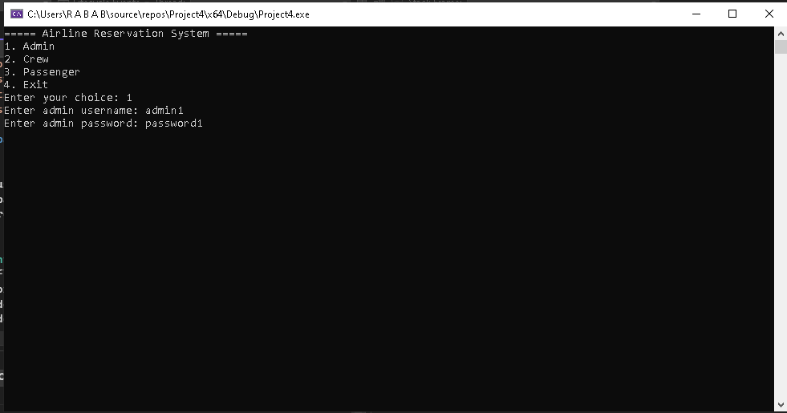

- ADMIN MENU
In the admin menu the admin is given the options to: add a flight schedule, change the flight schedule, assign crew to a flight, add crew memebers.

Main admin menu
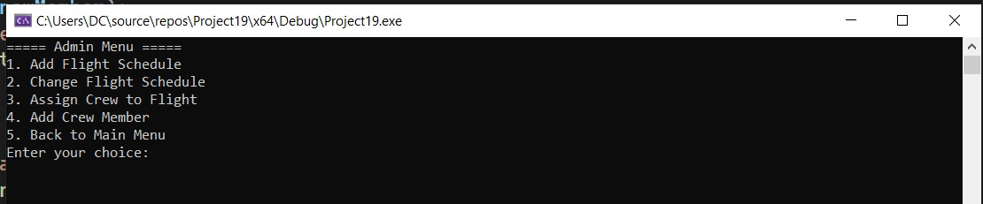
Adding a flight schedule
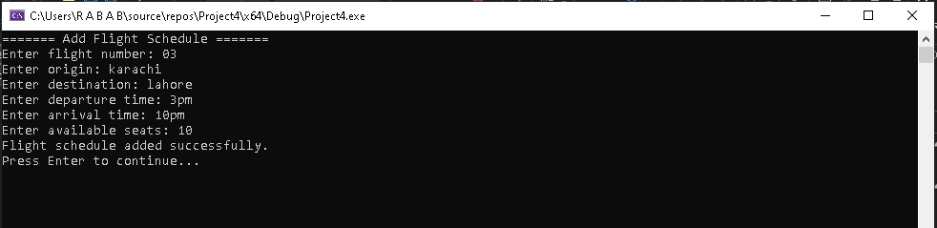
Changing a flight schedule
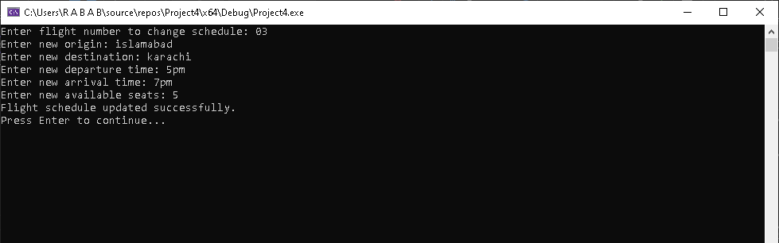
Assigning a crew
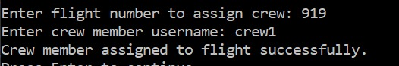
- CREW MEMBER MENU
Main menu
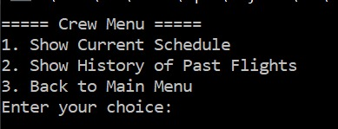
Current schedule
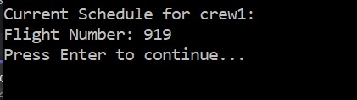
History

- PASSANGER MENU
the main menu for a passanger
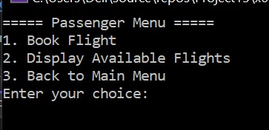
Showing available flights
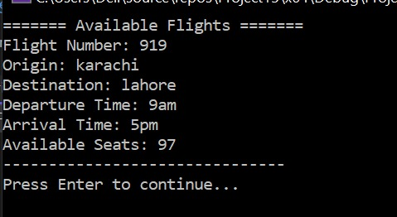
Booking a flight
